Experiment 10

Aim:- To study and Implement Containerization using Docker

Theory:-
Containerization has revolutionized the way we deploy and manage applications, offering lightweight, portable, and efficient environments for software development and deployment. Docker, a leading containerization platform, has become synonymous with this technology. This document aims to delve into the fundamental disparities between traditional virtual machines (VMs) and containers.

Virtual Machines (VMs):

- VMs operate by emulating physical hardware, allowing multiple operating systems (OS) to run concurrently on a single physical machine.

- Each VM includes a complete OS, virtualized hardware, and application stack, resulting in larger resource overhead and slower startup times.

Containers:

- Containers encapsulate applications and their dependencies within isolated runtime environments, sharing the host OS kernel.

- They are lightweight, utilizing OS-level virtualization to achieve faster startup times and efficient resource utilization.

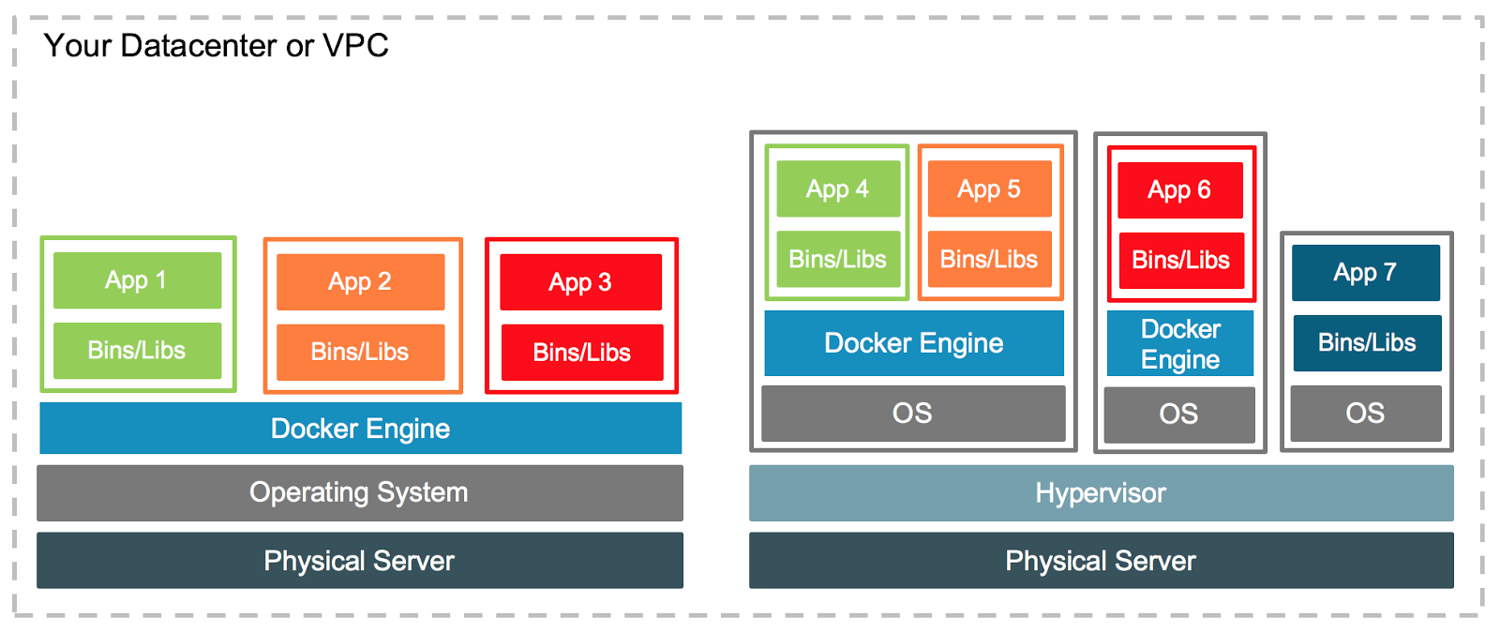
(Containers and Vm’s Together)

Docker Image:

An immutable template containing an application and its dependencies, used to create containers.
Example: docker pull nginx to fetch the official Nginx image from Docker Hub.

Docker Container:

An instance of a Docker image, running as a process on the host OS.
Example: docker run -d nginx to launch a detached Nginx container.

Dockerfile:
A text file containing instructions to build a Docker image.

Example:
sql

FROM ubuntu:latest
RUN apt-get update && apt-get install -y nginx
CMD ["nginx", "-g", "daemon off;"]

Getting Started:-

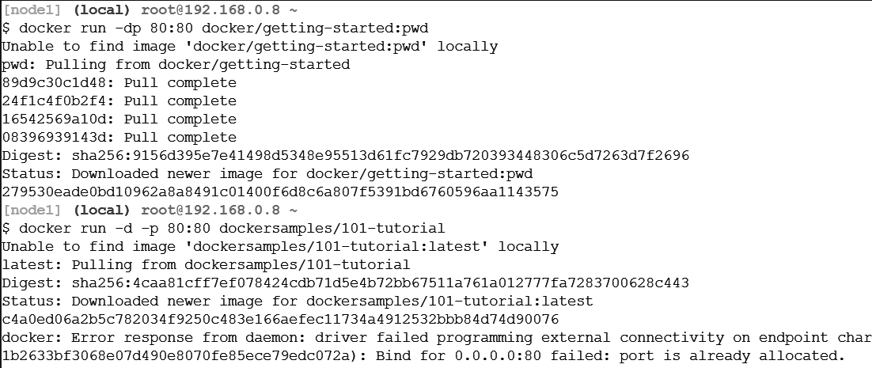

Our Application:-

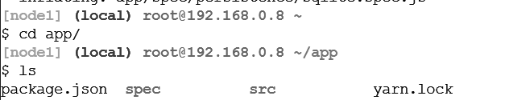
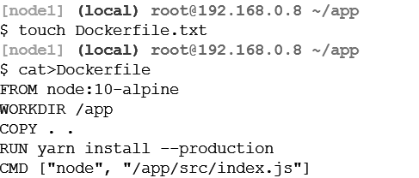


Updating our Application:-

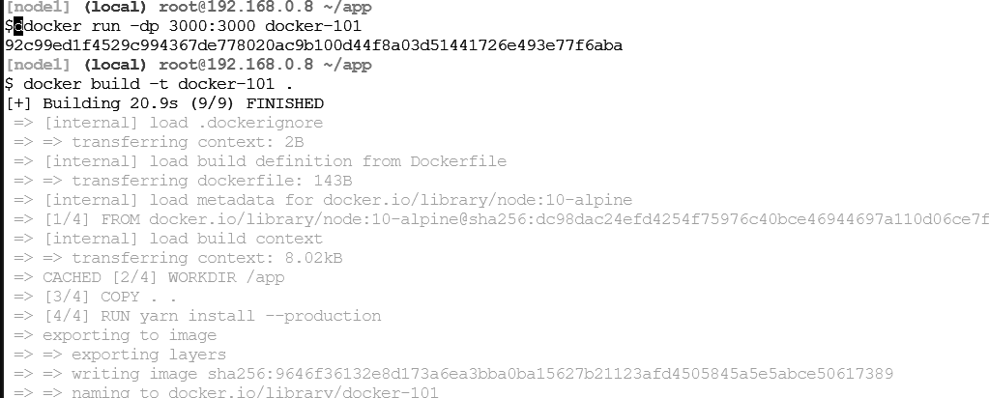
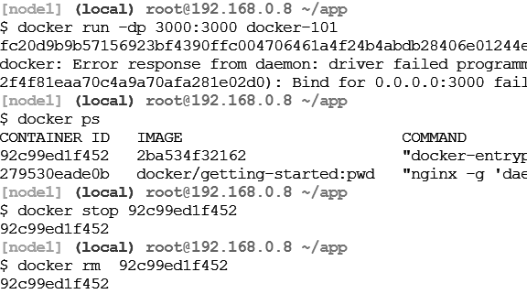

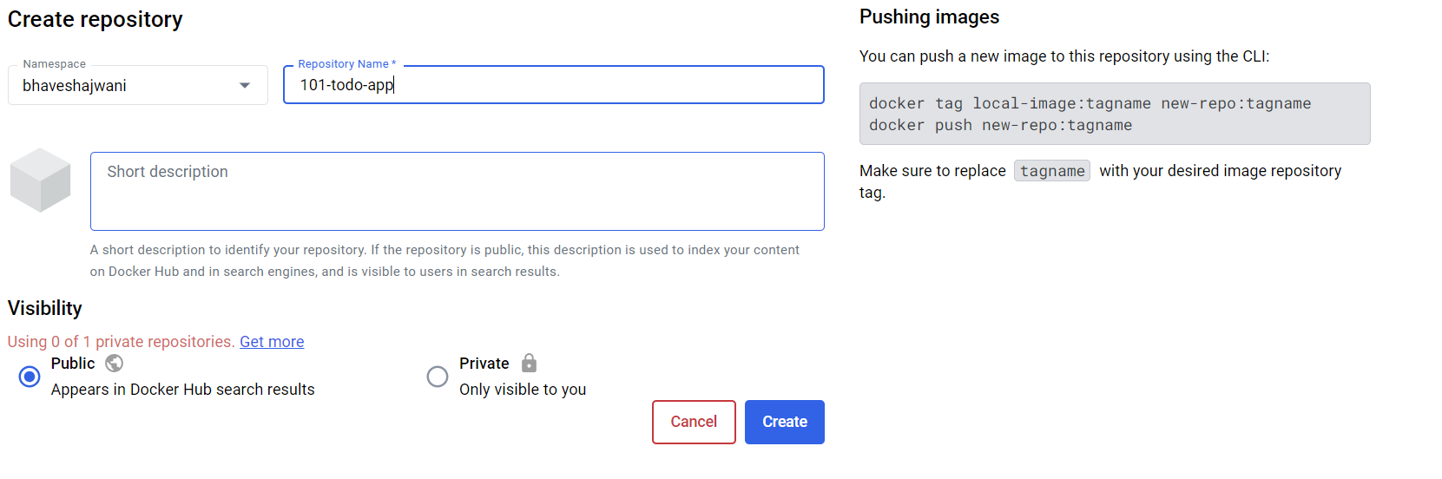

Persisting our DB:-

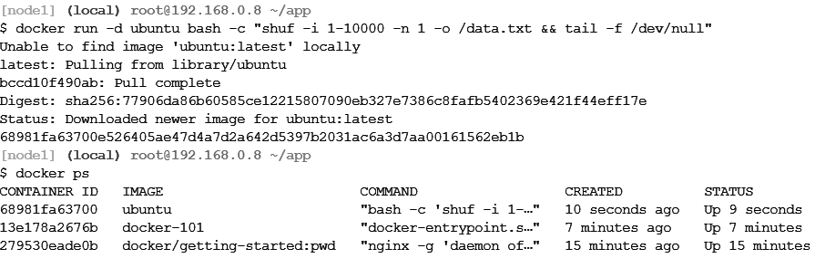
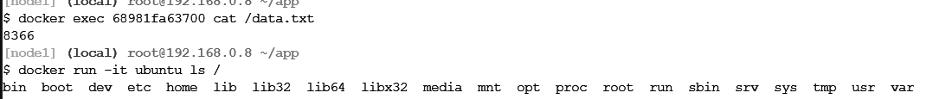
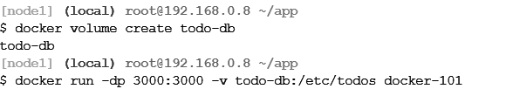

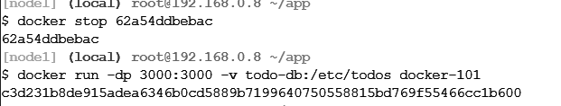


Using Bind Mounts:-

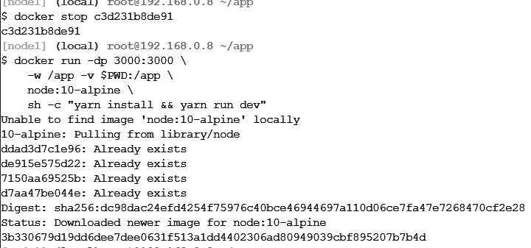
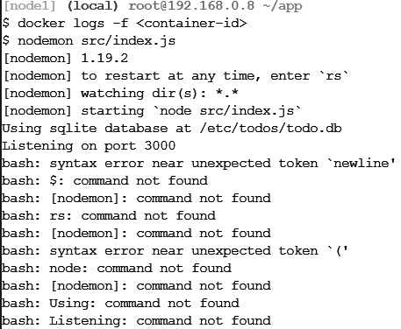


Multi-Container Apps:-

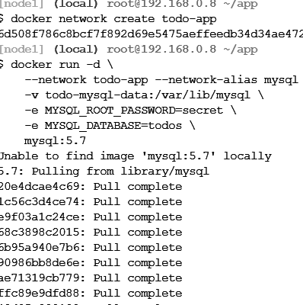
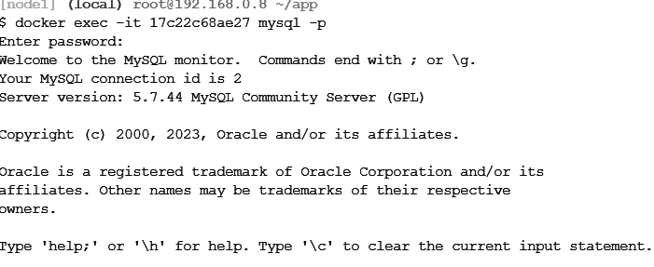
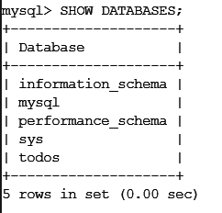
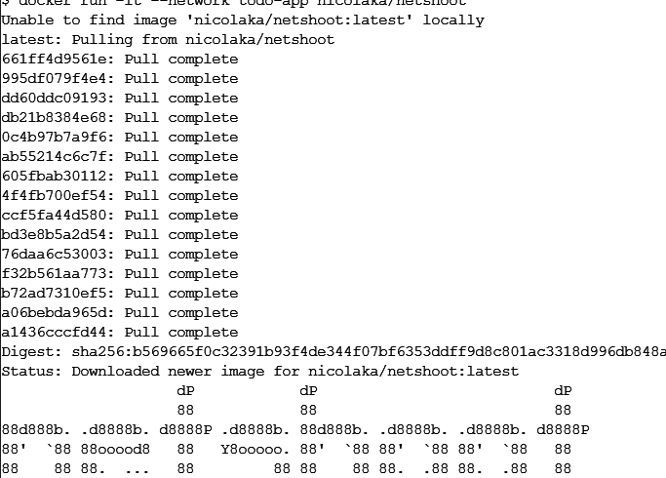
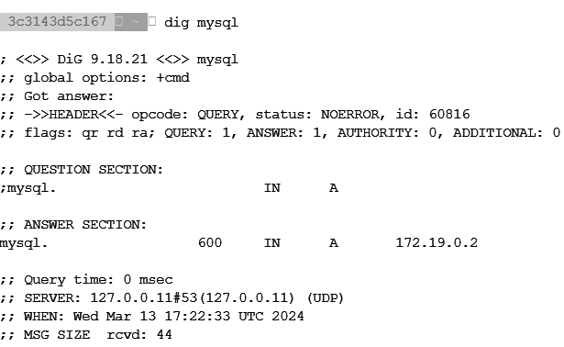
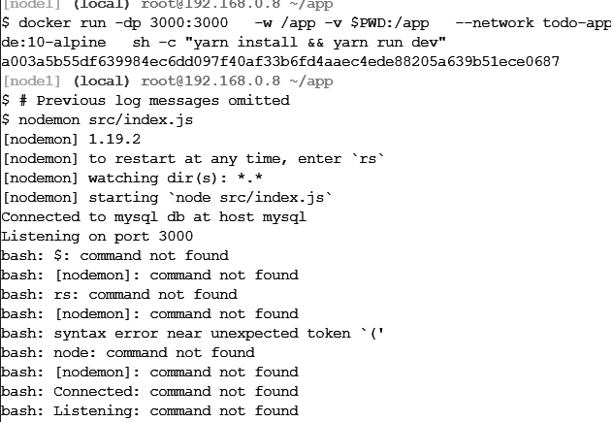


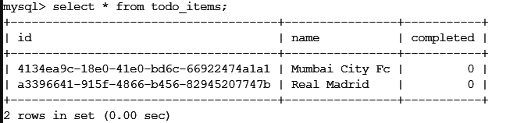

Docker Compose:-
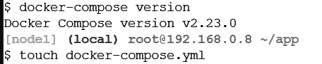
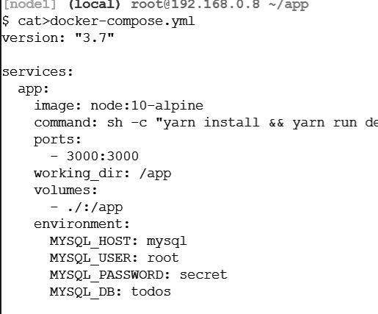
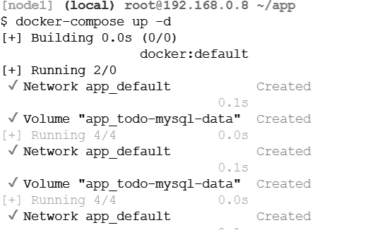
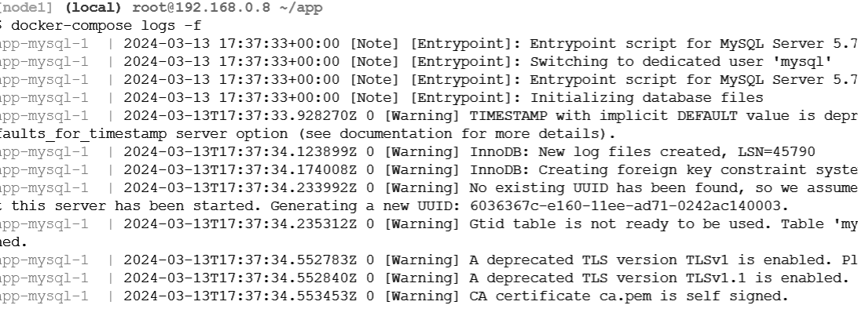
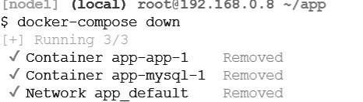

Conclusion:-
In conclusion, containerization with Docker represents a significant advancement in the realm of software deployment and management. By encapsulating applications and their dependencies within lightweight, isolated environments, Docker offers unparalleled portability, efficiency, and scalability. Through this experiment, we have explored the fundamental disparities between traditional virtual machines and containers, gaining insight into their respective advantages and drawbacks. Docker's ease of use, coupled with its robust ecosystem of tools and resources, makes it an indispensable tool for modern software development and deployment. As organizations increasingly embrace microservices architectures and cloud-native technologies, understanding the nuances of containerization becomes essential for optimizing resource utilization and enhancing application performance. Thus, Docker stands as a cornerstone in the evolution of software engineering, empowering developers to build, deploy, and scale applications with unprecedented speed and agility.

